Admin End:
In the admin area, I don't know how I can issue discounts
Discount code create kr skte hai or other companies ko share kr krte referred by or iss code ko admin registered company ko b share kr skte hai ki bo other comnpany ko code share kre :
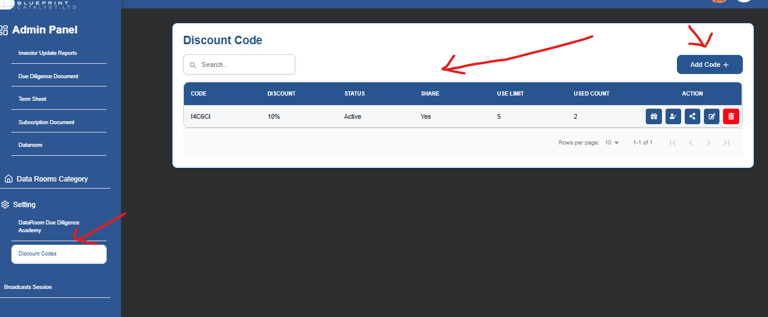
Create Disocunt code
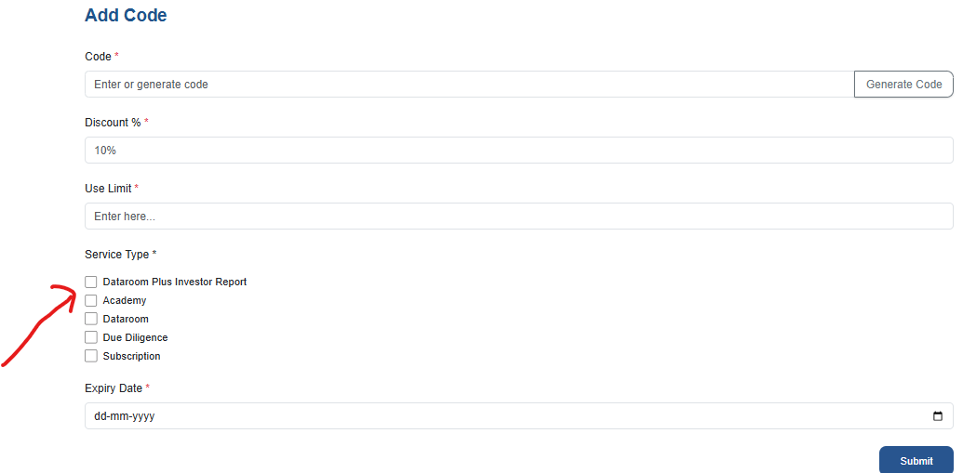

Registered Companies:

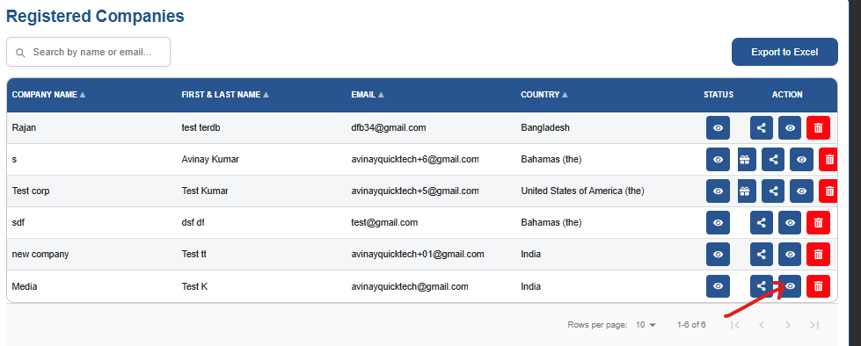

Red mark: Click krne pr Companies ki (total count) total doc, report, shared report etc,
Y detail ek separate company ki hai.
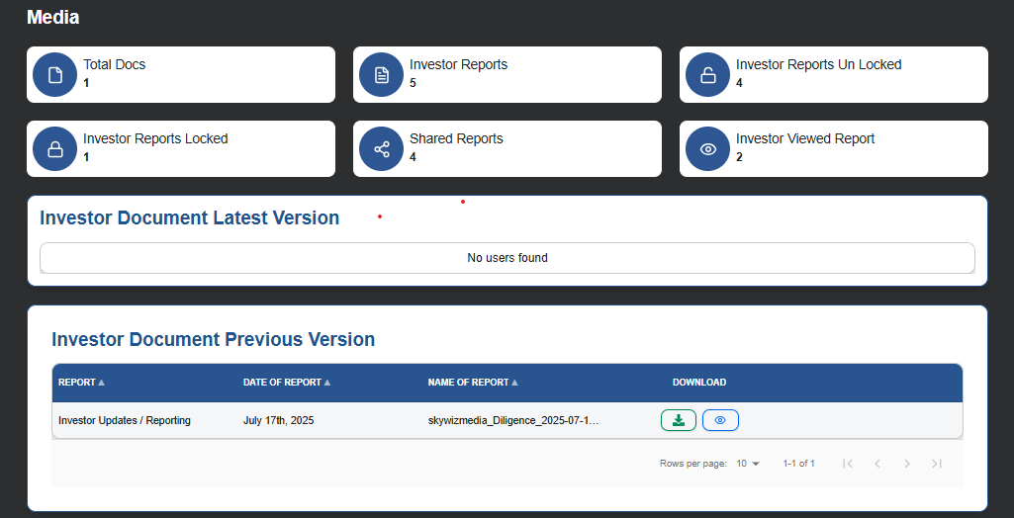

View detail: Click shared icon pr company ne kon kon se other company ko referred code shared kiya hai platform main invite ke ley:
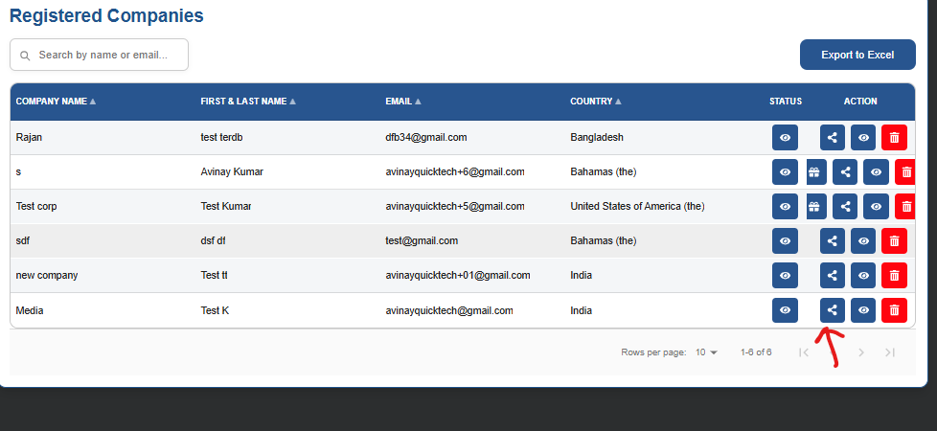
Click Status icon (left side): jb koi company register hone pr module ke subscription subscription detail hai, ‘DATAROOM MANAGEMENT & DILIGENCE’ + ‘INVESTOR REPORTING’
- ‘INTERNATIONAL ENTREPRENEUR ACADEMY PROGRAM’
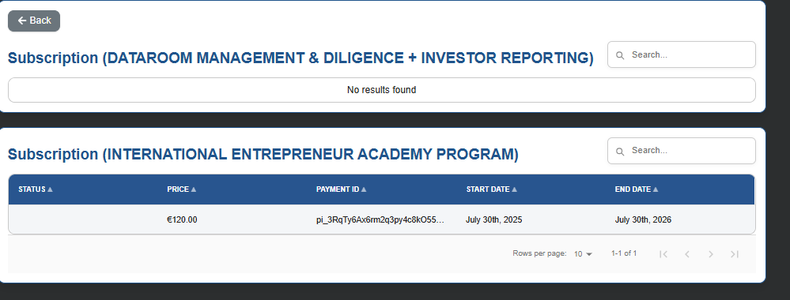

Referred by company: jb koi company kisi other code ke sath registered ho or usne bo code kon se payment ke ley use kya hai, y bo detail hai (click this icon and view page)
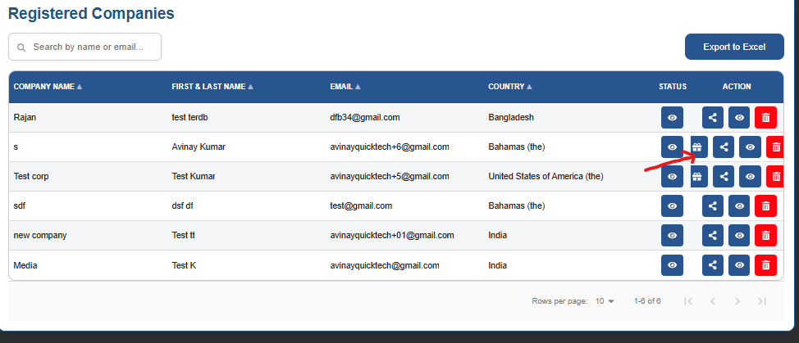
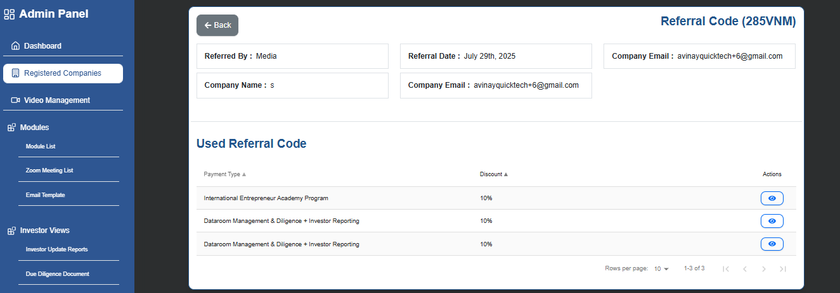

- 2. I uploaded documents into the data room, but I don't see the company in the admin area.
  - Jb company diligence document with summary generate kre tb ek list create hoti hai , Report, date of report,name or report,

  - 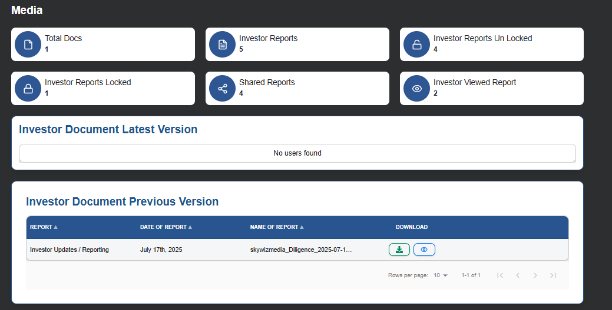

  - Download view icon main click krke investor ki detaail view kr skte hai.

  - 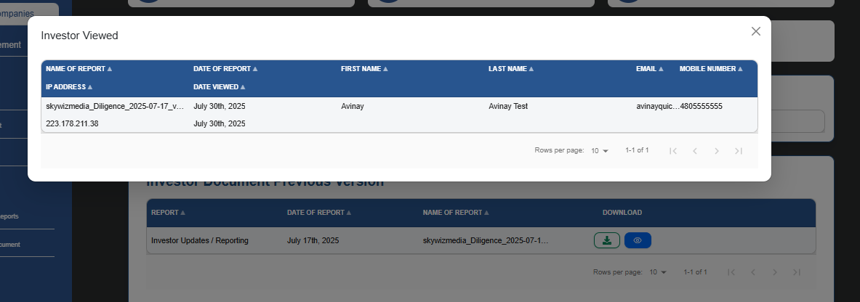

Investor Document Latest Version: Abi tk company ne report shared ni ki hai investor ko,

Investor Document Previous Version: Jo report shared or investor end se view ho chuki hai.

Company End:

I want to try to create a diligence document. We will need to abandon this and create a 'dynamic' executive summary instead.

Document upload
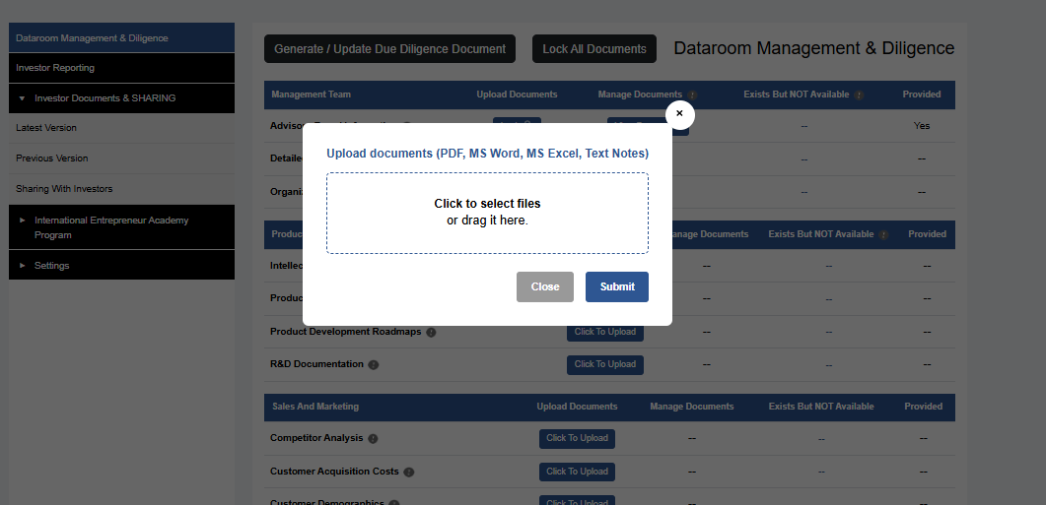

Document Upload krne ke baad file ko lock kiya hai AI summary generate ke ley.
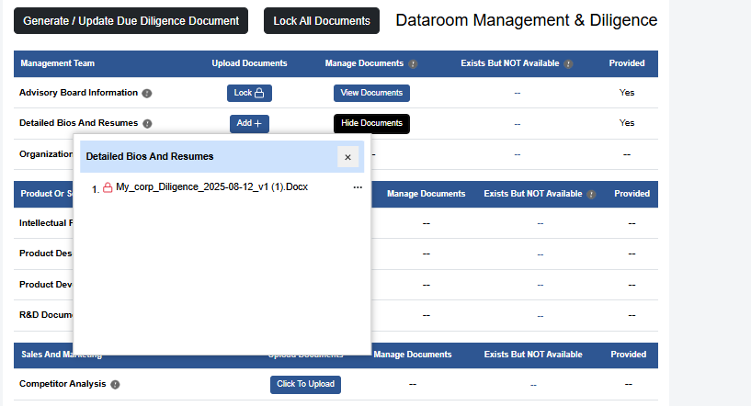

Jb company Generate/Update Due Diligence Document pr click kre tb AI summary generate hoti hai with questions ke sath
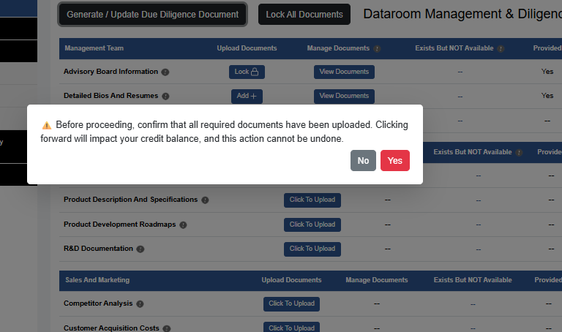

Uske baad company ko ek email send hogi approval ki fr page redirect hone pr ,Company ko approval page view hoga jissme , SummaryOr AI generated Qusetion ke answer update kr ske,
Uske baad company sections ko approve kre uske baad Export Documents pr click krke Final,
Due Diligenece Document report create hogi. Jisko admin end se view kiya ja skta hai

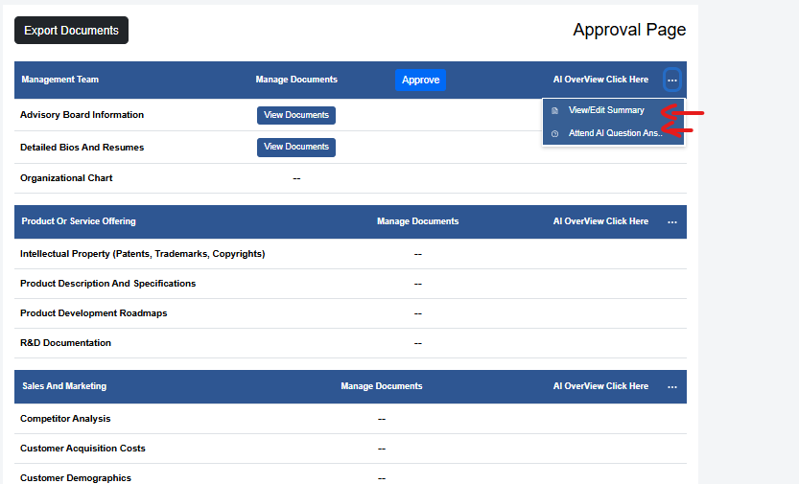

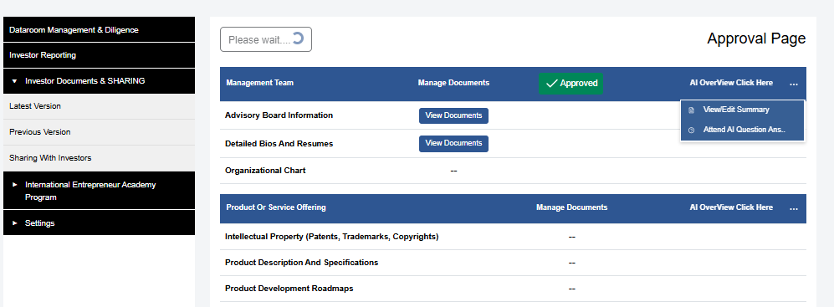

Uske bo report Latest Version main display hogi, For investor share.
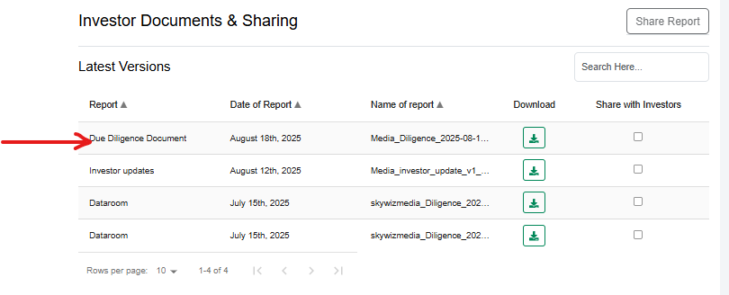

Admin End:
Perticular company pr click krke Admin Due diligence document Report check kr skta hai or file ko download b kr skte hai.
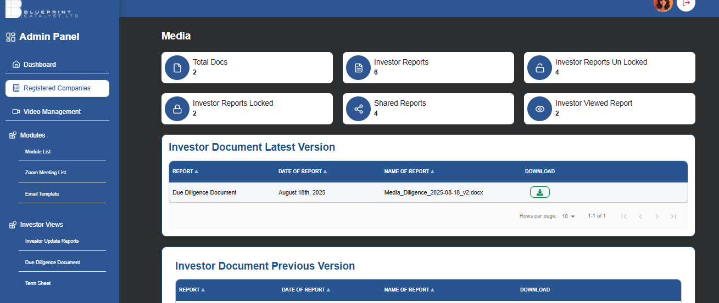

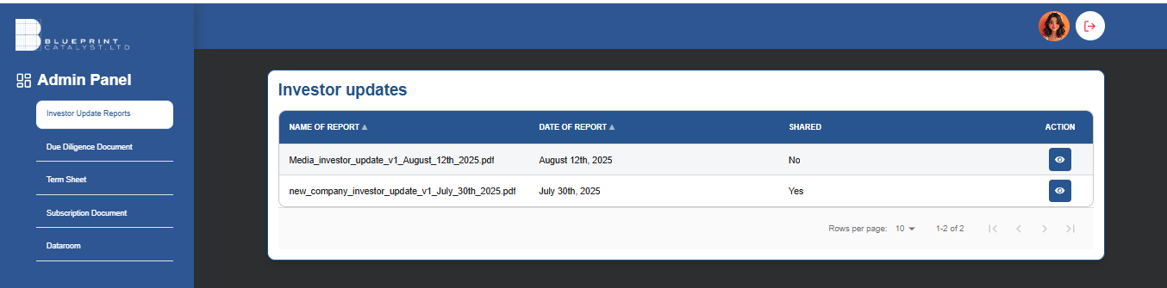
Y five module hai jisme company doc generate krti hai or investor ko report shared hoti hai, isme overall company ki report list hogi.

Admin end main company ki serperate documents (Mtlv jo lock unclok ke regarding hai bo view ni hue hai abi)

